Princess Sumaya University for Technology

King Abdullah II Faculty of Engineering

Electrical Engineering Department



|  |
| --- |
| **Embedded systems**  **Final Design Project**  **Hand Gesture RC Car** |

|  |  |  |  |
| --- | --- | --- | --- |
| *Authors:* |  |  | *Supervisor:* |
| Ahmad Barakat  Hussein Sabri  Basil Nesheiwat | 20190771  20200564  20200318 | P&E  P&E  P&E | Dr.Bilal Sababha |

*January 20, 2024*

***Abstract***

Hand gesture control electronic car (Robot) is a car which can be controlled by simple hand motion. The gesture device consist a sensor which sense the motion of hand. The sensor will read and record the hand motion in a specific direction which will give the signal to electronic car to move in a respective direction. The gesture device is connected wirelessly to the electronic car with the help of RF link to communicate in a simple way.

Table of Contents

1 Design Requirements 3

2 Introduction & Background 3

3 Design 4

3.1 Electrical Design…………………………………………………………………………………………………………5

3.2 Mechanical Design …………………………………………………………………………………………………………6

3.3 Software Design…………………………………………………………………………………………………………7

3.4 Code…………………………………………………………………………………………………………9

4 Problems & Recommendations 12

5 Links 12

6 Conclusion 12

# Design Requirements

You are required to do a Final Design Project for this class as per the following requirements:

* Develop a non-trivial embedded system or device that performs some useful function.
* You shall work in groups of 3 students.
* For final demos, create a poster and use it to help explain your work. Have your system up and running to show it off.
* Upload your final project files to **eLearning**and to **GitHub** <https://github.com/> (Tutorial on how to use GitHub: https://www.youtube.com/watch?v=iv8rSLsi1xo ).
* Report, Should include these sections:
  + Abstract
  + Introduction and Background
  + Your Design (Mechanical, Electrical, Software)
  + Problems and recommendations
  + Conclusion
* Source code (Compress your project folder, this should include everything including the hex)
* Poster file
* Good pics
* A URL to at least one video (Upload a video to YouTube use the following Tags: PSUT, Princess Sumaya University for Technology, www.psut.edu.jo, Embedded Systems Class), the video shall demonstrate the prototype and present all aspects of the design.
* Share your GitHub URL and upload the link in a text file Named GitHib to eLearning.

# Introduction & Background

Advanced electro-mechanical technology found in electronic cars have made them a symbol of modern transportation. These cars may now operate automatically or in partially autonomous modes due to the incorporation of a Pic Microcontroller, which provides a level of advanced control. Electronic vehicles are very flexible across a range of sectors, especially in situations where speed and accuracy are critical.

Because of their accurate and efficient navigation, autonomous electronic automobiles are the talk of the town in businesses. The requirement for automated and simplified operations that increase productivity and safety is what motivates their wide availability. Still, there are situations that call for a more practical approach. Semi-autonomous electronic automobiles, which strike a balance between automation and human control and offer more flexibility in some applications, are the result of this requirement.

Electronic vehicle control systems have progressed beyond conventional approaches, with innovations like voice, touch, and motion control becoming increasingly common. Hand gesture controlled electronic devices are one of them that stands out as an interesting and useful option. The goal of this project is to use a PIC Microcontroller to create an electronic automobile that can be operated by hand gestures, providing a novel and simple method of control.

The concept offers an innovative method of guiding and controlling an electronic car's speed without the need for traditional remote control devices. Rather, the movements of the hand are converted into orders that control the car's direction and speed. The technology as a whole is based on wireless communication, which uses an RF connection to transfer hand gestures from the transmitter to the receiver smoothly.

The project, which consists of two primary components—the transmitter and the receiver—investigates the relationship between hand gestures and electronic vehicle control, offering a novel strategy to improve human-technology interaction. This project highlights the potential of contemporary control systems while also highlighting the influence of wireless communication on the direction of electronic vehicle technology.

# DESIGN

Starting to build a hand gesture-controlled electronic automobile with a PIC Microcontroller requires careful component selection and integration, each of which is essential to the project's success. The PIC Microcontroller, which functions as the system's brain, is the fundamental component. The physical framework of the car—which includes wheels—provides the necessary movement for the electronic vehicle. An accelerometer and gyroscope are integrated into a specially made hand glove to record and analyze the user's motions. DC motors are used to power the car's motion, and an oscillator maintains exact timing. Resistors, capacitors, and transistors are used to precisely tune the circuitry and create the required electrical paths. Smooth connections are made possible via cables, connectors, and breadboards; LEDs provide visual signals.

Transformers or adapters provide the power, and push buttons and switches give additional user control features. The transmitter and receiver modules' effective communication is the basis of the entire system. This combination of parts creates an integrated and complex network, highlighting the importance of each part in achieving the hand gesture-controlled electronic car.

## Electrical Design

A crucial part of the project is exploring the complex field of electrical design within the larger context of creating a hand gesture-controlled electronic automobile utilizing a PIC Microcontroller. This section serves as the framework for the entire system; it includes the electronics, connections, and schematics that give the creative control mechanism its life. The PIC Microcontroller is smoothly integrated with the other parts of the electronic car due to a carefully thought-out electrical architecture that makes it easier to convert hand gestures into useful orders. Examining this aspect of the project allows us to better understand the engineering details that make it possible for the transmitter and the receiver to communicate with each other. This helps us determine if the project was successful in fusing cutting-edge technology with real-world applicability.

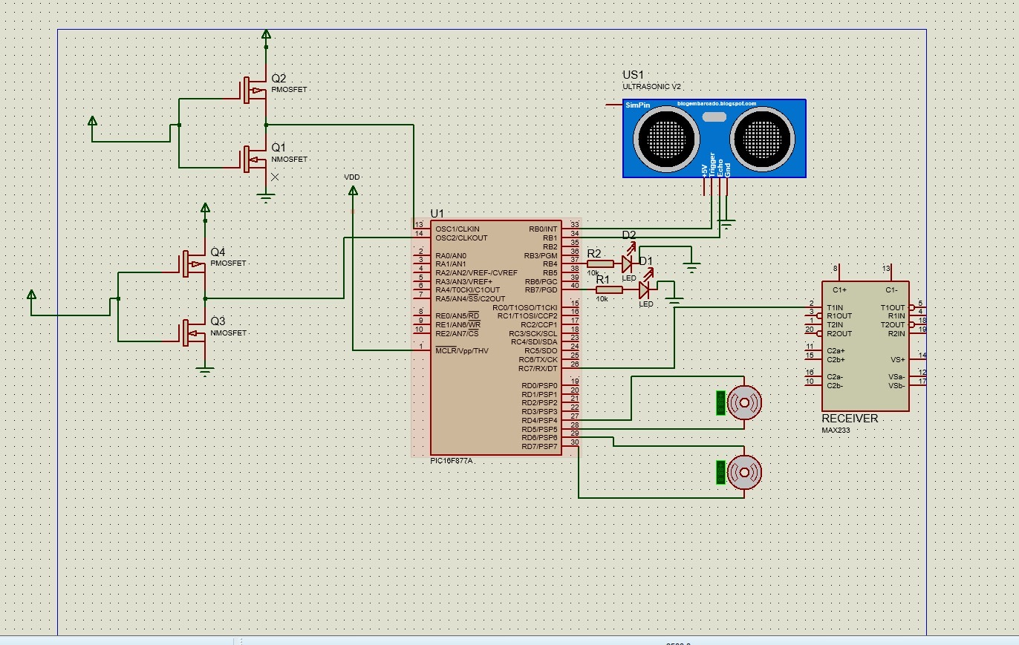

**Figure 1:** Electrical Design For the car

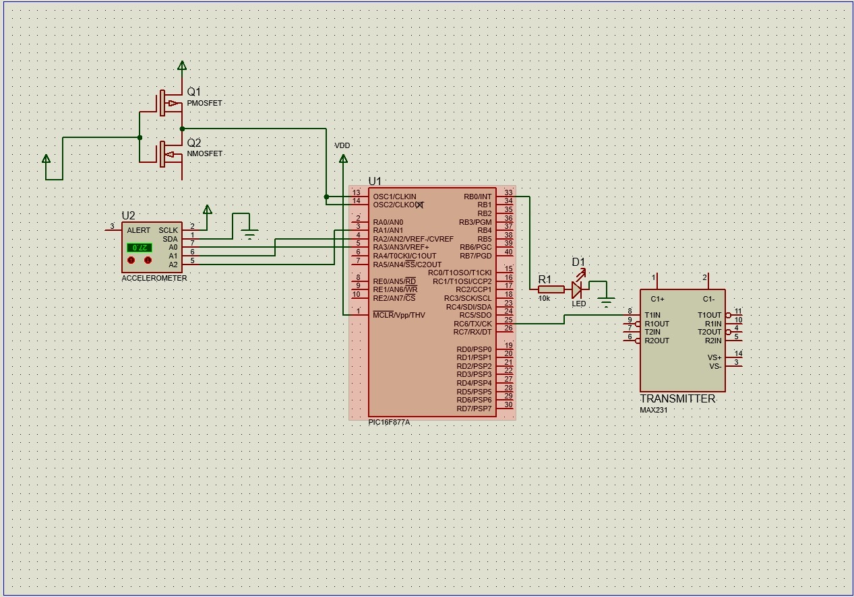

**Figure 2:** Electrical Design For Hand

## Mechanical Design

The complexities of mechanical design play a crucial role in the construction of a hand gesture-controlled electronic automobile driven by a PIC Microcontroller. This aspect of the project focuses on the actual design and setup of the electronic vehicle, making sure it moves in reaction to hand motions with maximum efficiency and accuracy. The body, wheels, and structural elements of the automobile, which make up the mechanical structure, are carefully chosen to offer stability, toughness, and agility. The use of DC motors is essential for converting electrical information into mechanical action and moving the vehicle in the desired direction.

Achieving a smooth and responsive interaction between the mechanical components and the electrical control system requires careful consideration of parameters including weight distribution, suspension, and tire performance. The research into the mechanical design highlights the interaction between software and hardware, where form and function come together to create a unique and well-designed hand gesture-controlled electronic car.

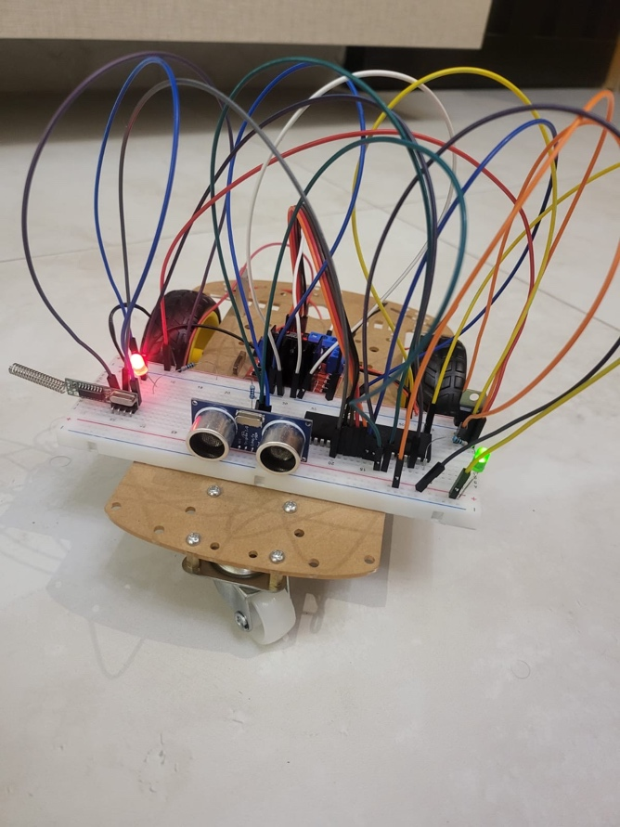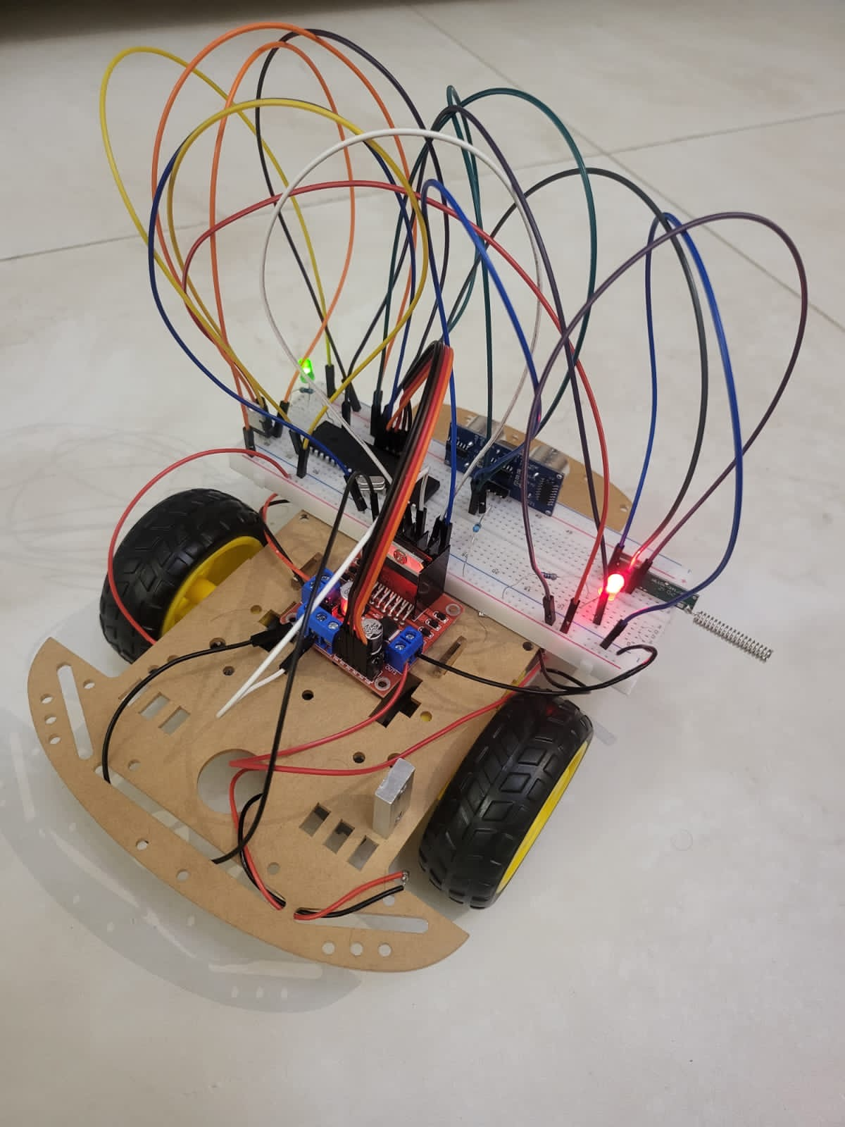

**Figure 3:** Mechanical Design For The Car

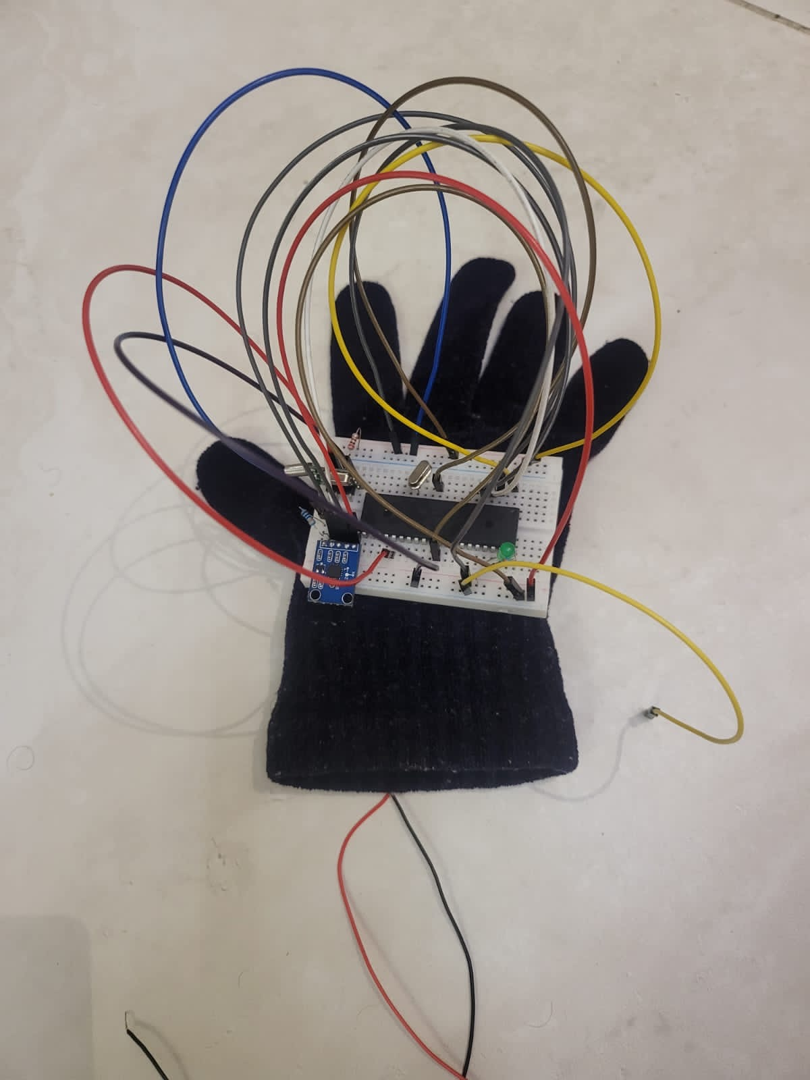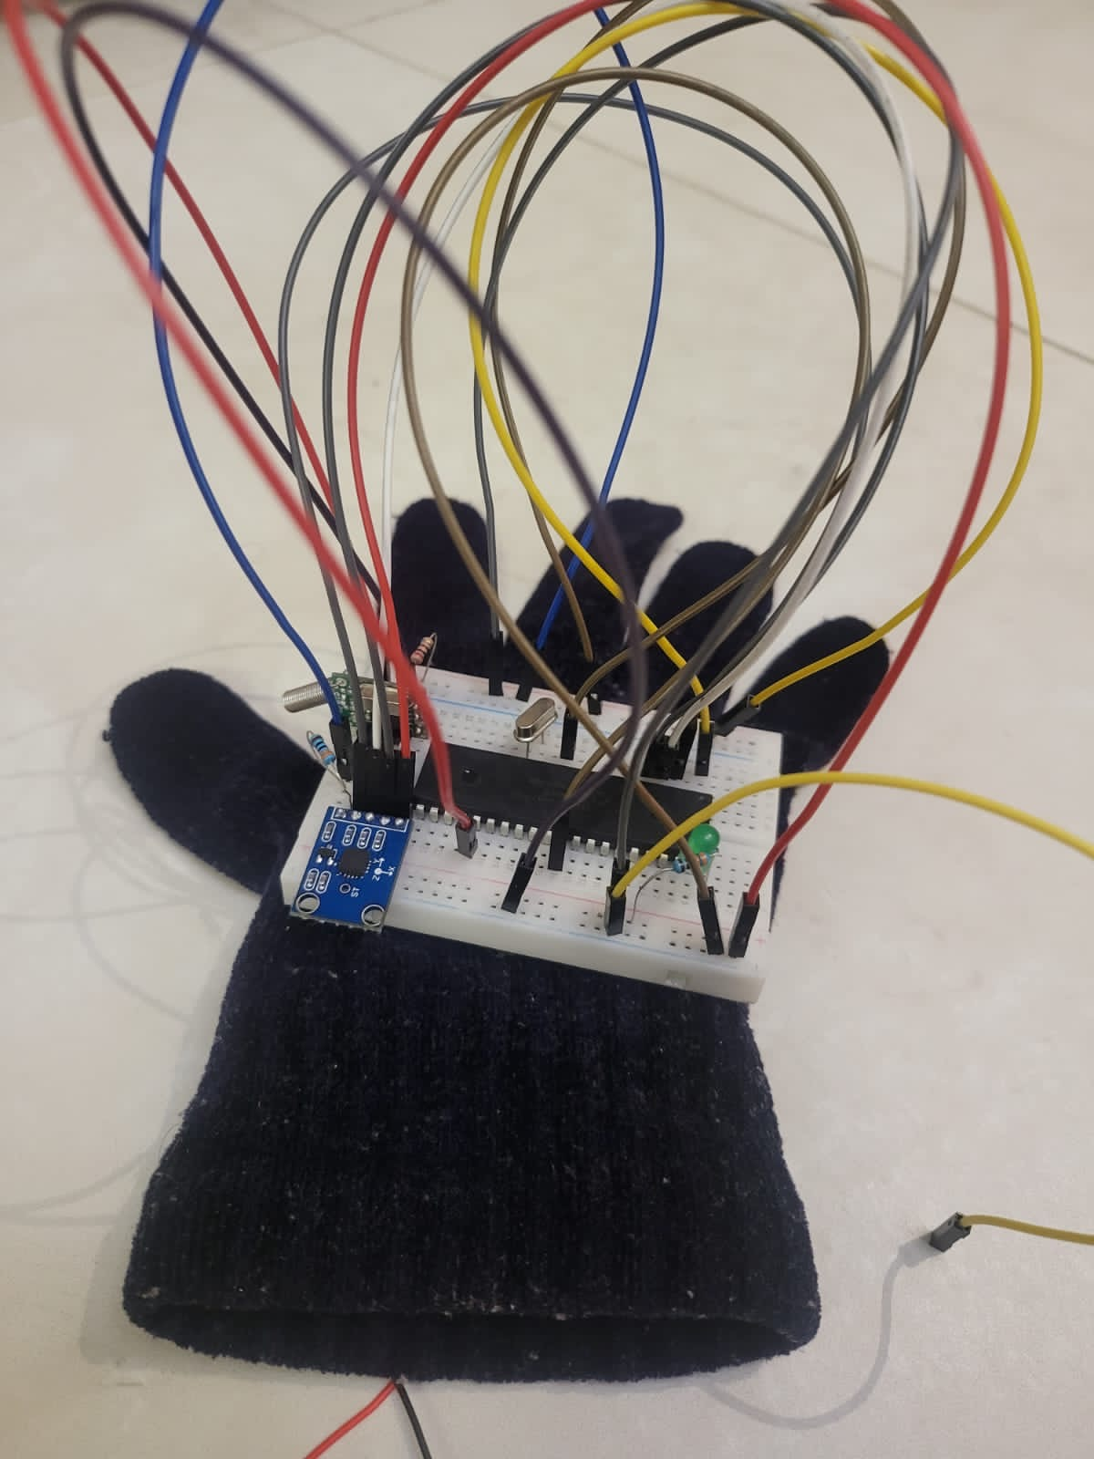

**Figure 4:** Mechanical Design For Hand

## Software Design

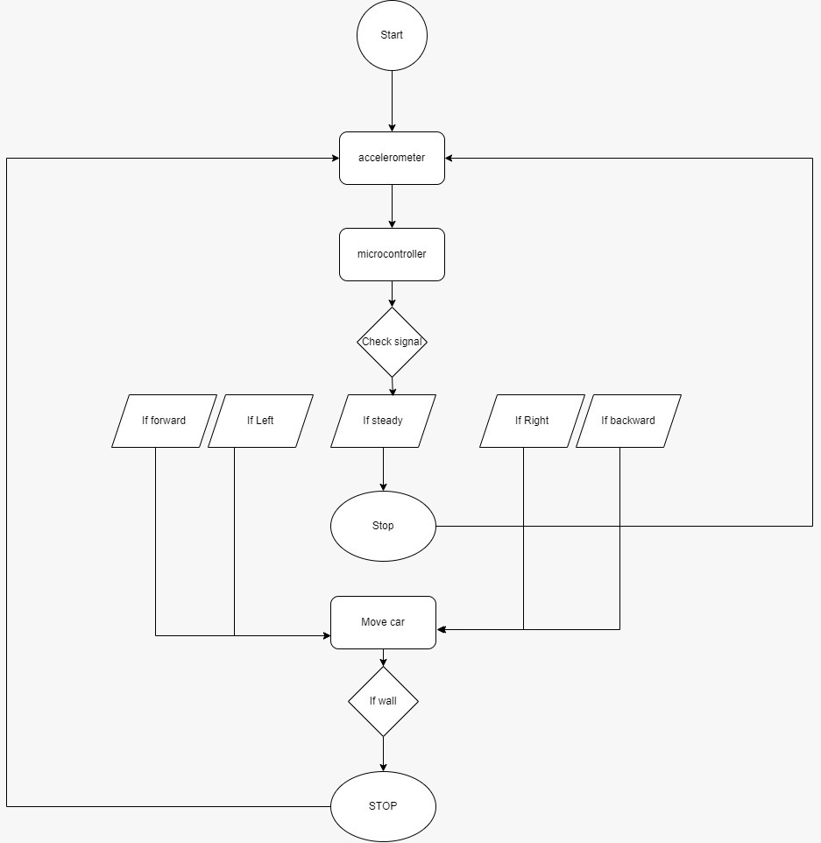

**Figure 5:** Flow Chart For our design

## Code

In this section we can find the full code of the desired project, which acts as a digital design for the PIC Microcontroller and other components to work together smoothly, is essential to the hand gesture-controlled electronic automobile project. This programming controls the movement of the automobile by translating user motions into exact orders. It is the essence of the collaboration between software and hardware, serving as the virtual conductor of the project and combining practical, inventive control methods with clever coding.

|  |  |
| --- | --- |
| ***Hand Code***  void USART_init(void);  void USART_Tx(unsigned char mychar);  unsigned int ATD_read(int channel);  unsigned int xx;  unsigned int yy;  unsigned int zz;  unsigned int xvoltage;  unsigned int yvoltage;  unsigned int zvoltage;  void main() {  TRISB=0X00;  PORTB=0x01;  USART_init();  ADCON1 = 0xF0;//All channels are Analog, 500 KHz, right justified  while(1){  xx= ATD_read(0x49);  yy= ATD_read(0x51);  zz= ATD_read(0x59);  xvoltage=(unsigned int)(((float) xx/10.23)*5);  yvoltage=(unsigned int)(((float) yy/10.23)*5);  zvoltage=(unsigned int)(((float) zz/10.23)*5);  if(xvoltage>=130&&xvoltage <149){// hand tilted right , move car right  USART_Tx(0x00);  }  else if(xvoltage>175&&xvoltage <=200){// hand tilted Left , move car left  USART_Tx(0x01);  }  else if(xvoltage>=149&&xvoltage<=175){// hand not tilted , car stationary  USART_Tx(0x02);  }  if(yvoltage>=120&&yvoltage <140){// hand tilted full downward , fullspeed  USART_Tx(0x03);  }  else if(yvoltage>=140&&yvoltage <150){// hand tilted half downward , halfspeed  USART_Tx(0x04);  }  else if(yvoltage>=185&&yvoltage <200){// hand tilted full upward , fullspeed backward  USART_Tx(0x05);  }  else if(yvoltage>=168&&yvoltage <185){// hand tilted half upward, halfspeed backward  USART_Tx(0x06);  }}}  void USART_init(void){  TRISC=0x80;// RC7 input,RC8 output;  SPBRG=103; // 1200BPS  TXSTA=0X20; // 8 -bit ,TX enable , Async, LOw speed;  RCSTA=0X90; //SP enable, continous RX  PORTC&=0xC0;  }  void USART_Tx(unsigned char mychar){  while(!(TXSTA&0x02));  TXREG=mychar; // send when finish  }  unsigned int ATD_read(int channel){  ADCON0=channel;  ADCON0 = ADCON0 | 0x04;// GO  while(ADCON0 & 0x04);  return((ADRESH<<8) | ADRESL);  } | ***Car Code***  float dist;  unsigned char h;  unsigned int cntr4;  float distance;  int period;  unsigned char y;  int e;  float calc_dist(void);  void USART_init(void);  void ms_delay(unsigned int mscntr0);  void interrupt(void){  cntr4++;  if(cntr4==19500){// chech distance every 2.5sec  cntr4=0;  dist=calc_dist();  }  if(dist<35){ // If distance less than 35 stop  PORTD=0x00;  PORTB&=0x8F;  y=0;  while(y<7){  y++;  }  PORTB|=0x70;  INTCON=0xA0;}  INTCON=0xA0;  }  void main (){  TRISB=0x02; //RB0=trigger // RB1=echo  PORTB=0x70; // for lights  T1CON= 0x00; //TMR0=0  OPTION_REG=0x88; // TMR0 with no prescaler  INTCON=0xA0; // Global enable on, TMR0 interrupt on  TRISC=0x00;  TRISD=0X00;  PORTD=0x00;  RCREG=0x00;  USART_init();  while(1){  RCREG;  if(RCREG==0x00){//move car right  PORTD=0x10;  ms_delay(400);  }  else if(RCREG==0x01){//move car left  PORTD=0x40;  ms_delay(400);  }  else if (RCREG==0x02){//stop car  PORTD=0x00;  ms_delay(400);  }  else if (RCREG==0x03){ //forward full-speed  PORTD=0x50;  ms_delay(400);  }  else if (RCREG==0x04){ //forward 75%-speed  PORTD=0x50;  ms_delay(300);  PORTD=0x00;  ms_delay(100);  }  else if (RCREG==0x05){ //backward full-speed  PORTD=0xA0;  ms_delay(400);  }  else if (RCREG==0x06){ //backward 75%-speed  PORTD=0xA0;  ms_delay(300);  PORTD=0x00;  ms_delay(100);  }  else {  PORTD=0x00;  ms_delay(400);  }  }}  float calc_dist(void) {  h=0;  period=0;  distance=0;  TMR1L=0;  TMR1H=0;  PORTB|=0x01; // RB0 on send pulse (trigger)  while(h<20){ //delay 10usec  h++;  }  PORTB&=0xFE; //RB0 stop pulse  while(!(PORTB&0x02));  T1CON=0x01; // start TMR1 when pulse enter BR1 (ech)  while(PORTB&0x02);  T1CON=0x00; // stop TMR1 when pulse end (low)  period=((TMR1H<<8)|TMR1L);  distance=period/117.65; //TMR1(no of ticks)*4/Fosc (*340m/sec(speed of sound)/2  return distance;  } void USART_init(void){  SPBRG=103; //1200BPS  TXSTA=0X20; // 8 -bit ,TX enable , Async, Low speed;  RCSTA=0X90; //SP enable, continous RX  TRISC=0x80;// RC7 input,RC^ output;  // PORTC=0x00;  }  void ms_delay(unsigned int mscntr0){  unsigned int cntr=0;  while(cntr<mscntr0){  cntr++;} } |

# Problems & Recommendations

Challenges for the hand gesture-controlled electronic automobile project include power consumption, possible misunderstanding, and sensor reactivity. Algorithms for noise reduction and calibration are required to increase accuracy. It may be investigated to use alternative power sources like energy gathering devices or rechargeable batteries. The success of the project depends on the transmitter and receiver modules having stable and organized wireless connection. Especially in dynamic or busy contexts, strengthening the signal and putting error-checking procedures in place can improve data transmission reliability and ensure smooth control.

Electronic cars that operate using hand gestures need to improve their user experience, especially in terms of simplicity. A gesture library that can be customized and machine learning techniques might improve how flexible the interface is to user preferences. Incorporating sensory or visual indications can enhance control accuracy and user satisfaction, and real-time feedback is essential. Predictive control using artificial intelligence can improve efficiency and responsiveness. To continuously improve the system and make sure it meets user expectations and changes to accommodate changing preferences, regular user testing and feedback gathering are crucial. These suggestions seek to address existing issues and support the project's ongoing development and progress.

# Links

Youtube Link :

GITHUB Link :

# Conclusion

In Conclusion ,the hand gesture-controlled electronic car project is an advanced, interactive robotic control system that lets people operate the vehicle with simple hand gestures. The gesture device's use of a sensor elevates the level of interaction complexity. The RF link's ability to provide wireless communication improves the project's adaptability and user experience by enabling smooth control from an acceptable distance. Effective software algorithms for signal processing and gesture detection, as well as harmonic coordination between hardware components like the electronic car and gesture sensor, are necessary for this project's successful completion. The project's logical and scientific design can be seen by the information flow from the start of a hand motion to the equivalent car movement.